
RAMAIAH
Institute of Technology
USN | 1 | M | S

(Autonomous Institute, Affiliated to VTU)
(Approved by AICTE, New Delhi & Govt. of Karnataka) Accredited by NBA & NAAC with ‘A’ Grade

SUPPLEMENTARY SEMESTER EXAMINATIONS – AUGUST 2019

Course & Branch | : | B.E. : Computer Science and  Engineering | Semester | : | IV
Subject | : | Design and Analysis of Algorithms | Max. Marks | : | 100
Subject Code | : | CS1542/CS42/CS413 | Duration | : | 3 Hrs

Instructions to the Candidates:
- Answer one full question from each unit.

 |  | UNIT – I
1. | a) | - Design an algorithm to merge two sorted lists into one list and compute the time complexity for the same.  - Determine the stable matching set S for the following set of men and women using Gale-Shapley algorithm. | CO1 | (10)
  Men’s preference list | Women’s preference list
    V | A | B | C | D | E
    W | B | C | D | A | E
    X | C | D | A | B | E
    A | W | X | Y | Z | V
    B | X | Y | Z | V | W
    C | Y | Z | V | W | X
 | b) | - What is the difference between perfect matching and stable matching? Consider an execution of the G-S algorithm that returns a set of pairs S for the given set of men M and women W. Prove that “The set S is a stable matching”.  - Prove the following.  - T(n)= 4n²+3n+2 is O(n³)  - T(n)= 4n²+3n+2 is Ω(n) | CO1 | (10)
2. | a) | - Write the Gale-Shapley algorithm to produce stable matching set for a given set of men and women.  - Design an algorithm to compute the distance between two points in a plane and deduce the time complexity for the same. | CO1 | (10)
 | b) | - How many k-size independent sets are possible for the following graph for k=3,4  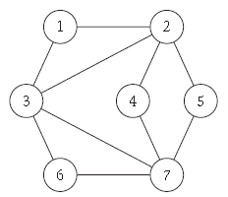  - Prove that the execution of the Gale-Shapeley algorithm takes O(n²) for n number of men and women. | CO1 | (10)
 |  | UNIT – II
3. | a) | Compute the sorted list for the following list of elements using merge sort and count the number of inversions using Divide and Conquer approach.  {8,6,5,2,1,3,11}. | CO2 | (10)
 | b) | - Design a recursive algorithm to compute the DFS traversal of a given graph G= (V,E).  - Let G be a connected graph, and let L1, L2, . . . be the layers produced by BFS starting at node s. Prove that,  There is no edge of G joining two nodes of the same layer. In this case G is a bipartite graph in which the nodes in even-numbered layers can be colored red, and the nodes in odd-numbered layers can be colored blue. | CO2 | (10)
4. | a) | Compute the DFS and BFS traversal for the following graph with source vertex as 1.  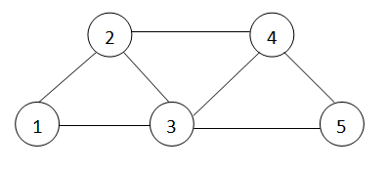 | CO2 | (10)
 | b) | - Design an algorithm to determine s-t connectivity using BFS.  - Compute the time complexity of merge sort algorithm using unrolling method and deduce the recurrence relation for the same. | CO2 | (10)
 |  | UNIT – III
5. | a) | Evaluate the shortest path from source node 1 to all other nodes for the following graph using Dijkstra’s algorithm.  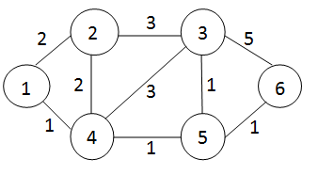 | CO3 | (10)
 | b) | Design a greedy algorithm to schedule the given intervals with each interval having a deadline d_{i} and time units required for it in terms of t_{i}. | CO3 | (05)
 | c) | Identify the optimal set of intervals that can be scheduled for the following set on intervals using greedy interval scheduling algorithm.  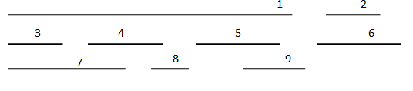 | CO3 | (05)
6. | a) | Compute minimum spanning tree for the following graph using Prim’s algorithm with source node as 1.  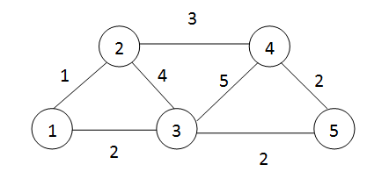 | CO3 | (10)
 | b) | Design a greedy algorithm to schedule the given intervals with each interval having a start time s_{i} and finish times f_{i}. | CO3 | (05)
 | c) | Prove that “Greedy algorithm for interval scheduling returns an optimal set A”. | CO3 | (05)
 |  | UNIT – IV
7. | a) | Apply bellman ford algorithm to find the distance from source vertex ‘a’ to destination vertex ‘t’ in a weighted digraph.  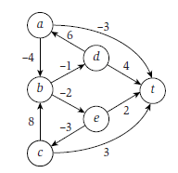 | CO4 | (10)
 | b) | Calculate the maximum value possible by considering the following instance and knapsack capacity W=10. | CO4 | (06)
  Item | Weight | Value
  1 | 4 | 40
  2 | 7 | 42
  3 | 5 | 20
  4 | 3 | 12
 | c) | Design a recursive procedure to find the optimal weight of the intervals for a given set of intervals with their weights. | CO4 | (04)
8. | a) | Design an iterative procedure to find the optimal weight for a given set of n intervals with their weights ‘w’. | CO4 | (05)
 | b) | Discuss survey-design problem for a given set of customers and products with an algorithm. | CO4 | (05)
 | c) | Identify the optimal weight and the number of intervals that can be scheduled for the following set of intervals.  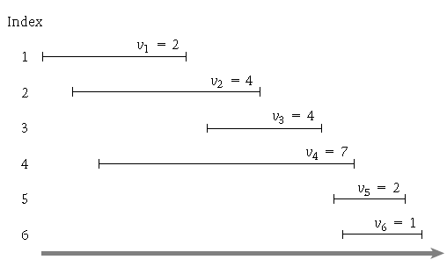 | CO4 | (10)
 |  | UNIT – V
9. | a) | Discuss Travelling salesman problem. Prove that travelling salesman problem is NP-Complete. | CO5 | (10)
 | b) | What is the general strategy to prove NP-Complete problems? Explain. Give some examples that are NP complete problems. | CO5 | (10)
10. | a) | Compute Hamiltonian cycle for the following graph. How can we prove that TSP is complete using Hamiltonian cycle problem?  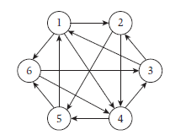 | CO5 | (10)
 | b) | What do you mean by polynomial time reduction? Give a corelation between vertex-cover and independent set problem. | CO5 | (10)

****************

